NAGVA Board Call
Meeting Minutes: 09/13/2017

- Roll Call – Jason F, Lew S, Mark E, Mark D, Jen C, Brian D, Eric N, Scott K, Jimmy S, Andrew C
- Officer/Department Reports
  - President
  - Vice President
  - Secretary
  - Treasurer
    - All bills from Championships 35 are finally paid
    - Balance sheet:
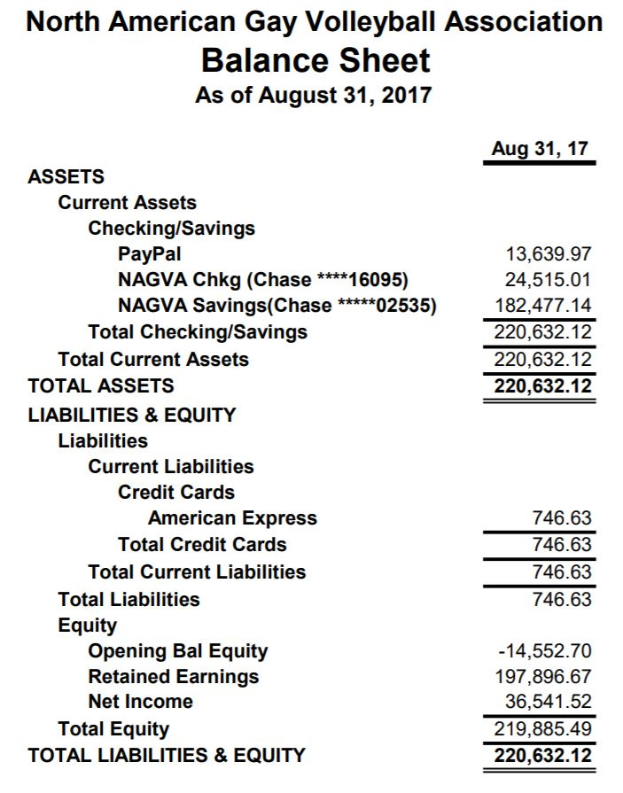
  - Registrar
    - Working on updating DOBs
    - Changed the age verification so that members must be 18 years old to create NAGVA profile
  - Technology
  - Eligibility
    - August 2017 Report
      - Medical Re-Rate: 4 received; 4 granted
      - 3 Year Inactive Re-Rate: 14 received; 12 granted, 2 denied
      - Grievances - 1 filed (team cheating); should be ruling by end of week
  - Regions
    - Sent out updated RC Guide
    - Recent Tournament Recap
    - # of Tournaments: 3 - WI Dells, Columbus, WeHo
    - # of NonRates: 113
    - # of Rerates: 15 (73% uprate, 20% same, 6% downrate)
    - Total # of RCs Utilized: 5 RCs (Dells and Columbus 1 RC each, WeHo increased to 3 RCs due to last minute notification facility changes occurred) - 4/5 RCs were out of region.
  - Tournaments
    - New tournament possibly in Orlando
    - Waiting on Louisville to turn in sanction application
    - Addressing issues from the WeHo tournament with TD
  - Officials
    - New R1 test is ready
    - Will be reviewed by board at mid-year meeting
  - Communications
  - Canadian Representative
- MAL Reports
  - Trevor
  - Rich
  - Brian
  - Jimmy
- MY Meeting Update
  - Hotel – Harrah’s New Orleans
  - Send any dietary restriction to Brian C
  - Small group topics will be sent out a month before so groups can touch base before the meeting
- Championships Update
- New Business
  - Nelson Kuhnagel – Early Parole
    - Discussion was held and consensus that violence at a tournament is unacceptable.
    - Board voted unanimously not to reduced suspension
- Meeting Adjourns

